Created by Lionel Weber, the 17 February 2011
Modified by Lionel Weber, the 08 February 2013

Wigii Email validation proof (double opt in) concepts

Background:
The Swiss government requires an electronic proof (IP + date) of a confirmation of giving an email address. That means to use an email address to send information the owner needs to give it to us AND confirm on a link that it was really his intention to give it to us (double opt in).

Emails datatype
The Emails datatype is updated with 3 more subfields to handle the proof:
- proofStatus (tinyInt, 0 = none validated, 1 = validated, 2 = requested for delete, const defined in class Emails)
- proof key (string, which is the md5 of CLIENT_NAME+email value)
- proof (text with the client IP + date when the confirmation is done)

Process
This confirmation link is sent in three different occasion:
- After a subscription process. This case happens if you have defined a confirmation email in your subscription process. If the confirmation email contains the text $confirm$ then this text will be replaced with the relevant confirmation email. This is done in AddSubscriptionFormExecutor.php.
- If you open an element detail, you will see a small menu beside the email value. This menu allows you to send an email with the confirmation link if the email is not yet confirmed.
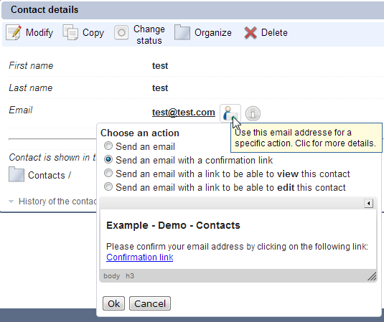
cf : TemplateRecordManager->formatValue, case externalCode for the menu
- In an Emailing activity you can include the confirmation email. Select each item you want to send an email. In the multiple dialog box, click on Email. In the email message use the word $confirmation$. This will send an email to each item with the individual confirmation link:
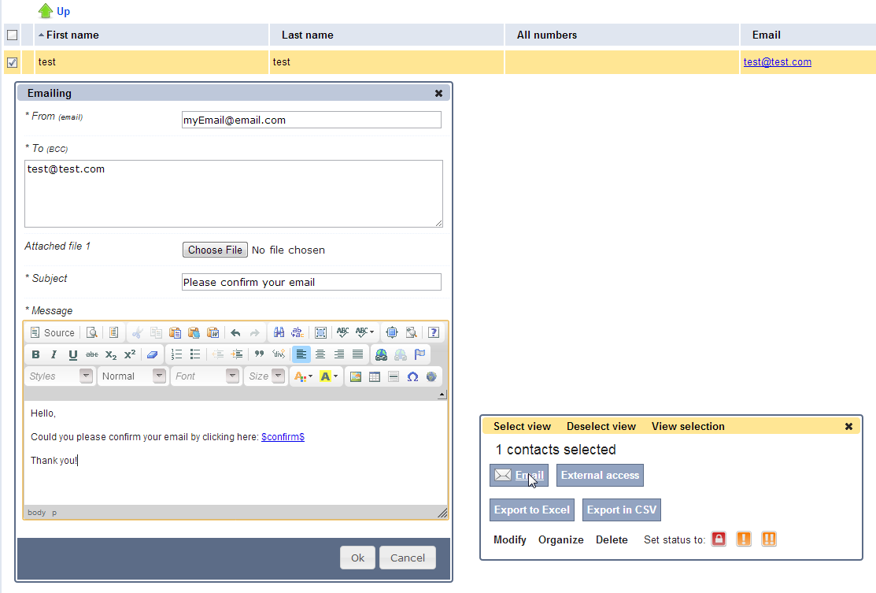
cf : EmailingFormExecutor->processRecipients.

The confirmation link will never generate an error, even if the email was already been confirmed.

Deprecated since 09/07/2013, 4.107:
In the design, decision was taken that an email confirmed would be confirmed for all items having this same email everywhere in the system. Be aware that this is done only on the action of confirmation. That means if you add a new item afterwards with the same email, this email will not be shown as confirmed.

The confirmation is done only on the specific field of the specific card. Even if the same email is somewhere else in the system, the confirmation is done only on the item used to send the confirmation link.

TemplateRecordManager.php provides 2 public method:
- getValidationEmailSubject($subject=null)
- getValidationEmailHtml($introductionText, $proofKey, $forMailto=false)

ElementServiceWebImpl.php provides 4 public method:
- getEmailValidationCode($principal, $email)
- getEmailValidationLink($principal, $email)
- getEmailValidationLinkFromCode($principal, $code)
- getEmailUnsubscribeLinkFromCode($principal, $code)
- validateEmailFromCode($principal, $code) the principal must be Public
- unsubscribeEmailFromCode($principal, $code) the principal must be Public

WigiiExecutor.php has an entry case: validateEmailFromCode and unsubscribeEmailFromCode

GUI
The Emails_displayValue.tpl.php has been modified to display the validation status:

